Sentiment Analysis on Hospitality Reviews
Lexicon, Clause-Level, Aspect-Based and Supervised NLP on 20,491 Hotel Reviews
Week 4 Task | TripAdvisor Hotel Reviews Dataset

Prepared by: Abhishek Pal
Computer Science Engineering (Data Science), ABES Engineering College
September 2026

1. Introduction and Objectives
Online reviews are the largest unprompted source of guest feedback a hotel has. Star ratings say how satisfied a guest was; the text says why. This report applies natural language processing in Python to public hotel reviews to measure sentiment polarity, identify recurring themes, and gauge overall satisfaction, and it compares several sentiment methods to find out which ones can actually be trusted.
Objective | Where addressed
Source hospitality review text | Section 2
Clean text: tokenisation, stop words, punctuation, lemmatisation | Section 3
Implement and compare sentiment approaches | Sections 4-5
Visualise sentiment and themes (word clouds, bar charts, distributions) | Sections 5-6
Interpret for customer satisfaction and business improvement | Sections 7-8
Step-by-step code explanation | Sections 3-4 and Appendix

2. Data Collection
The corpus is the TripAdvisor Hotel Reviews dataset, a widely used public collection of 20,491 traveller reviews, each with a written review and a 1-5 star rating. It was downloaded as a CSV file from a public GitHub repository. No account, scraping or private data was needed.
Rating | Reviews | Share
1 star | 1,421 | 6.9%
2 star | 1,793 | 8.8%
3 star | 2,184 | 10.7%
4 star | 6,039 | 29.5%
5 star | 9,054 | 44.2%

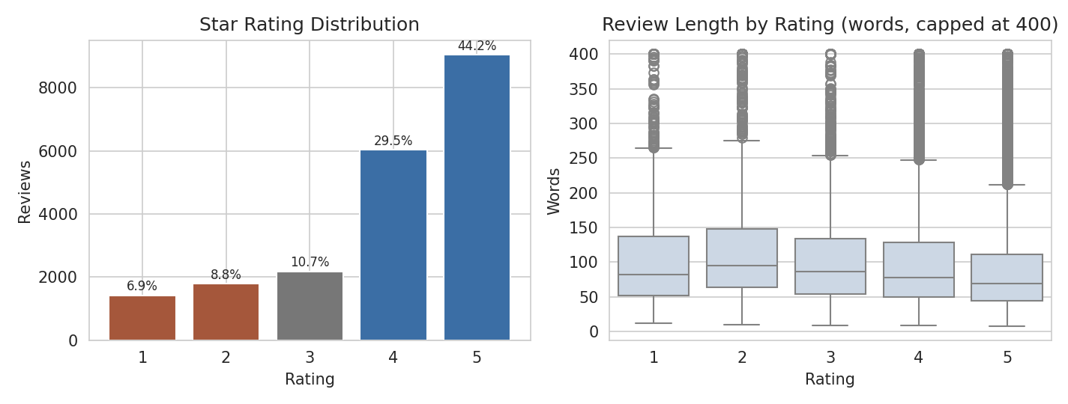
Figure 1. Rating distribution and review length by rating.
Ratings are strongly skewed to the positive side: 73.7% of reviews give 4 or 5 stars and 15.7% give 1 or 2. For evaluation, star ratings were turned into three sentiment labels: negative (1-2 stars), neutral (3) and positive (4-5). Median review length is about 70-95 words, and unhappy guests write longer reviews than happy ones (median 95 words at 2 stars versus 69 at 5 stars).

2.1 Data quality findings
Inspection before analysis showed that this copy of the dataset is not raw text. This affects every later result and is the main data-quality lesson of the task.
Finding | Evidence | Consequence
Already lowercased, stop words largely removed, punctuation partly stripped | Words such as 'and', 'was', 'is' and 'to' are almost absent; no capital letters or exclamation marks appear in any review | Lexicon tools that use capitalisation and '!' for intensity (VADER) lose part of their signal; stop-word removal in my own pipeline is partly redundant
Split negations: "did n't" | 18,984 separate "n't" tokens | Negation is detached from its verb; repaired to 'not' before scoring
Encoding damage | 836 reviews contain garbled apostrophes such as 'didn__Ç_é_' | Negation (didn't, wasn't) is lost unless repaired
No date, hotel or location fields | Only 'Review' and 'Rating' columns | Time trends and hotel-by-hotel comparison are not possible
Ratings used as labels | No human sentiment annotation exists | Ratings are a proxy: a 3-star review may be mixed rather than neutral, and a 2-star review may contain praise
Duplicates and missing text | 0 duplicate reviews; no missing values | None needed

Because there is no date column, the sentiment 'trends' in this report are relationships between sentiment and star rating, review length and topic. They are not trends over time.

3. Text Preprocessing

3.1 Pipeline
Step | Method | Purpose
1. Repair | Regex: fix garbled apostrophes and split 'n't' tokens into 'not' | Restore negation so sentiment tools can see it
2. Tokenise | Lowercase, keep alphabetic tokens only (regex) | Removes punctuation and numbers
3. Part-of-speech tag | NLTK averaged perceptron tagger | Lemmatiser needs word class (verb vs. noun)
4. Lemmatise | WordNet lemmatiser with POS tag ('stayed' -> 'stay', 'rooms' -> 'room') | Groups word forms for counting and topics
5. Remove stop words | NLTK English list plus domain words (hotel, room, stay, night, day, ...) | Removes words that carry no theme information
6. Filter | Drop tokens shorter than 3 letters | Removes fragments

Two versions of each review are kept, because the methods have different needs. Sentiment scoring uses the repaired text with stop words left in, because words like 'not', 'no', 'very' and 'but' carry sentiment. Word clouds, n-grams and topic models use the fully cleaned lemma list, where those words would only add noise.
def fix_text(t):
# 'didn__Ç_é_' -> 'did not' ; 'did n't' -> 'did not'
t = re.sub(r'\b([a-z]+)__\S*', repair_stem, t)
t = re.sub(r"\bwo n't\b", 'will not', t)
t = re.sub(r"\b([a-z]+) n't\b", r'\1 not', t)
return t

def preprocess(t):
toks = re.findall(r'[a-z]+', t.lower())
tagged = nltk.pos_tag(toks)
lemmas = [lem.lemmatize(w, wn_pos(p)) for w, p in tagged]
return [w for w in lemmas if w not in STOP and len(w) > 2 and w not in DOMAIN_STOP]

Before / after | Example
Raw | ...check process easy making reservation clerks didn__Ç_é_ bat eye assigning king room men...
Repaired | ...check process easy making reservation clerks did not bat eye assigning king room men...
Lemmas (start of a different review) | ace, place, husband, ace, seattle, excite, book, style, far, alley, floral, motel, happy, impression

After cleaning, the average review shrinks from 104.5 words to 86 lemma tokens, and the vocabulary is 43,434 distinct lemmas. The reduction is smaller than usual because the source text had already had many stop words removed.
The repair rules are approximate: for garbled apostrophes where the ending is ambiguous (for example 'it__...' could be it's or it isn't) the fragment is dropped, and only stems ending in 'n' are turned into negations.

4. Sentiment Analysis Methods
Five approaches were used, from simple to fine-grained, so that they can be compared on the same reviews.
Approach | How it works | Output
VADER (NLTK) | Rule-based lexicon with modifiers for negation, intensifiers and 'but'; designed for short social-media text | Compound score from -1 to +1
TextBlob | Averages polarity of adjectives and adverbs from a pattern lexicon | Polarity -1 to +1 and subjectivity 0-1
Clause-level VADER (experiment) | Split each review at commas and full stops, score each clause, then summarise across clauses | Mean clause score; share of negative clauses
Aspect-based sentiment | Eight hand-built keyword lists (staff, room, cleanliness, location, food, value, noise, facilities); score only the clauses that mention each aspect | Sentiment and mention rate per aspect
TF-IDF + Logistic Regression | Learns word and word-pair weights from ratings; 80/20 stratified split, C tuned over {0.3, 1, 3, 10} | Predicted class; interpretable term weights

vader = SentimentIntensityAnalyzer()
df['vader'] = df.text.apply(lambda t: vader.polarity_scores(t)['compound'])
df['blob'] = df.text.apply(lambda t: TextBlob(t).sentiment.polarity)

# clause-level experiment
clauses = re.split(r'[.,;!?]', text)
scores = [vader.polarity_scores(c)['compound'] for c in clauses]
features = mean(scores), share(scores < -0.05), min(scores)

# supervised baseline
tf = TfidfVectorizer(ngram_range=(1, 2), min_df=5, max_df=0.8, sublinear_tf=True)
lr = LogisticRegression(C=3, class_weight='balanced', max_iter=2000)

4.1 Threshold tuning
Lexicon scores must be converted into classes with cut-offs. Standard cut-offs (VADER: below -0.05 negative, above +0.05 positive; TextBlob: sign of polarity) were compared with cut-offs tuned for macro-F1 on the 80% training split only and then evaluated on the untouched 20% test split. The tuned cut-offs were 0.25 and 0.9 for VADER and 0.1 and 0.3 for TextBlob. The VADER upper cut-off (0.9) is very high, which is itself a sign of a problem discussed below.

5. Results

5.1 Sentiment distribution
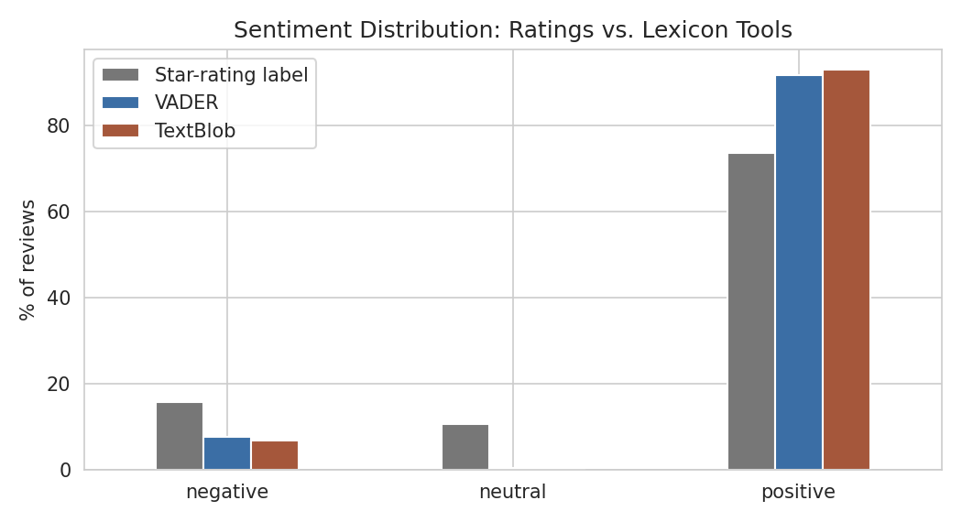
Figure 2. Share of negative, neutral and positive reviews according to star ratings, VADER and TextBlob.
Class | By star rating | VADER | TextBlob
negative | 15.7% | 7.7% | 6.7%
neutral | 10.7% | 0.4% | 0.2%
positive | 73.7% | 91.9% | 93.1%

Both lexicon tools label about 92-93% of reviews as positive, whereas 73.7% are positive by star rating. They find almost no neutral reviews (under 0.5%) although 10.7% are 3-star. The tools are systematically too positive.

5.2 Scores by star rating
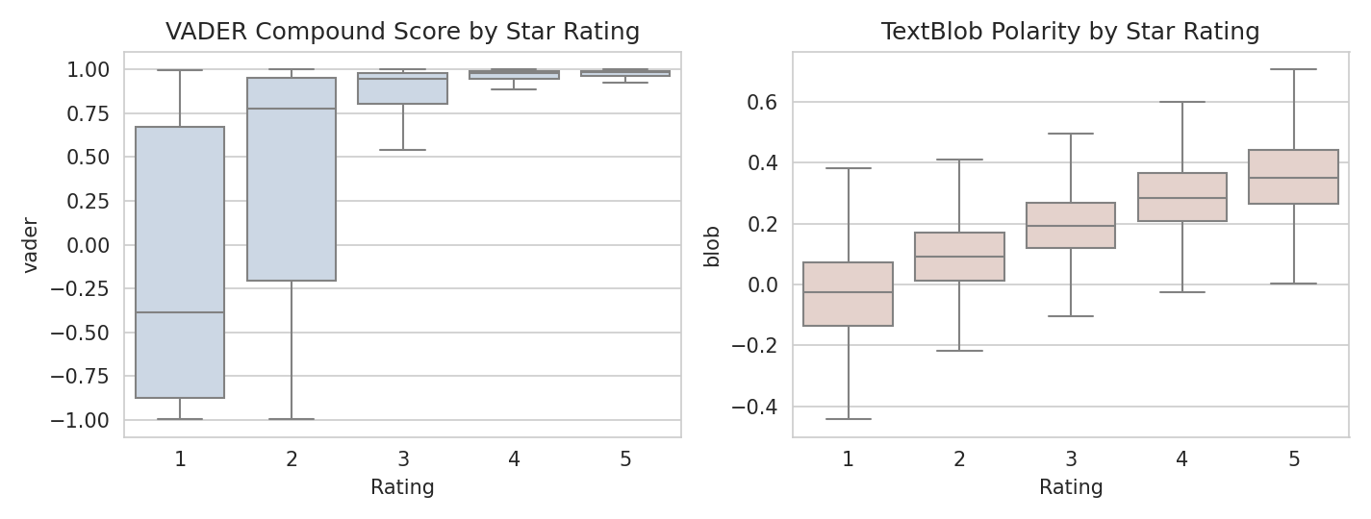
Figure 3. VADER compound score and TextBlob polarity by star rating.
Star rating | Mean VADER | Mean TextBlob | Mean clause score | Share of clauses negative
1 | -0.145 | -0.044 | -0.049 | 38.9%
2 | 0.386 | 0.090 | 0.070 | 29.5%
3 | 0.766 | 0.195 | 0.202 | 19.1%
4 | 0.935 | 0.295 | 0.331 | 11.4%
5 | 0.956 | 0.362 | 0.394 | 8.0%

Both tools rise with the rating, so the direction is right, but the scale is compressed: the mean VADER score is already 0.77 for 3-star reviews and 0.94 for 4-star reviews. Even 1-star reviews average -0.14. Guests who give 1-2 stars often list what went right as well as what went wrong, and a lexicon score sums the positive and negative words over a long text.
The clause-level view shows this directly: in 1-star reviews 39% of clauses are negative but 28% are still positive, while in 5-star reviews only 8% are negative.

5.3 Agreement with star ratings
Method (20% held-out test set) | Accuracy | Macro-F1
Majority class (always 'positive') | 0.737 | 0.283
VADER, standard cut-offs | 0.795 | 0.478
VADER, tuned cut-offs | 0.766 | 0.566
TextBlob, tuned cut-offs | 0.590 | 0.549
TF-IDF + Logistic Regression | 0.852 | 0.712

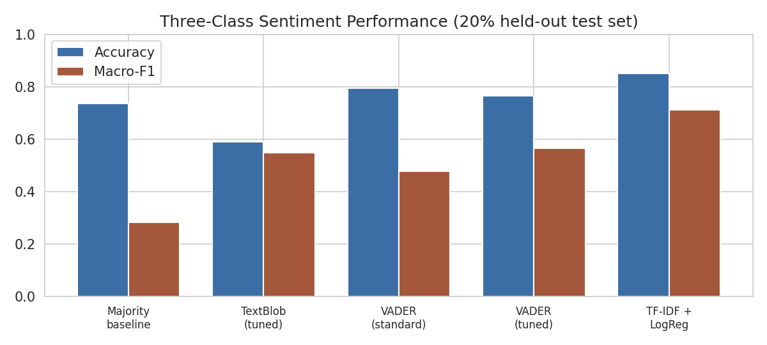
Figure 4. Three-class accuracy and macro-F1 on the held-out test set.
Accuracy alone is misleading here because 74% of reviews are positive: always predicting 'positive' scores 0.737 accuracy. Macro-F1, which averages the three classes equally, is the fairer measure. On that measure the standard VADER (0.478) is barely better than the trivial baseline (0.283), tuning helps (0.566), and the supervised model is clearly best (0.712).
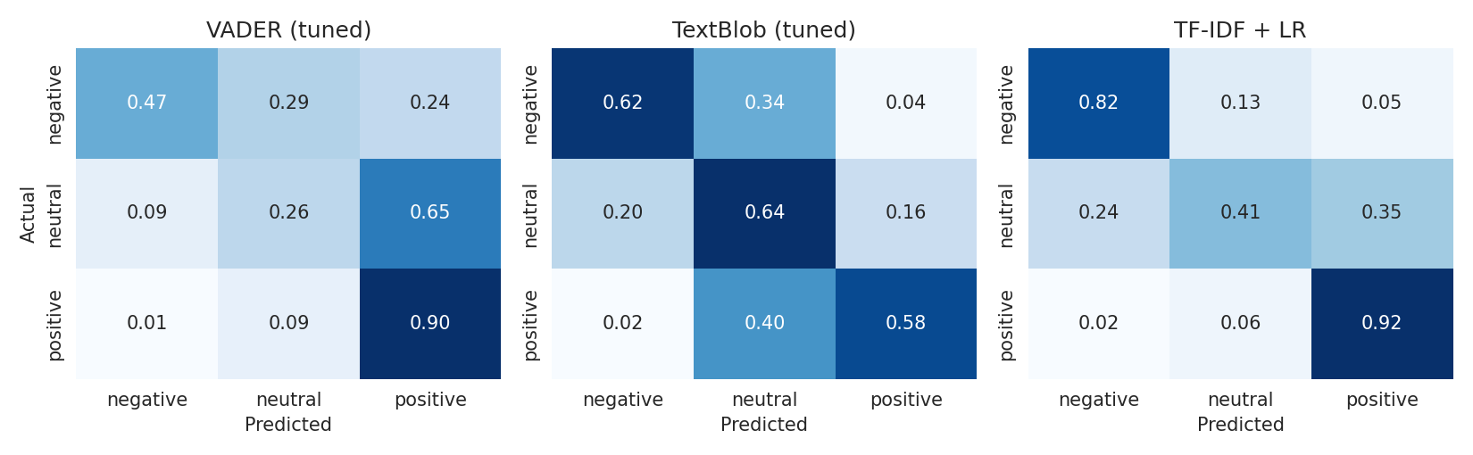
Figure 5. Row-normalised confusion matrices on the test set.
TF-IDF + LR per class | Precision | Recall | F1 | Test reviews
negative | 0.77 | 0.82 | 0.79 | 643
neutral | 0.41 | 0.41 | 0.41 | 437
positive | 0.94 | 0.92 | 0.93 | 3019

The tuned VADER finds only 47% of negative reviews, and puts 65% of neutral reviews into the positive class. The supervised model detects 82% of negative reviews and 92% of positive ones. Neutral (3-star) reviews are hard for every method (F1 0.41 for the best), which is expected because a 3-star review is a mix of praise and complaint rather than a distinct tone.

5.4 Experiments and what they showed
Experiment | Result | Conclusion
Repairing negation before scoring | Spearman correlation with rating for VADER: 0.464 on raw text, 0.464 on repaired text; classification scores identical | No measurable effect. VADER already recognises the separated "n't" token, and the garbled apostrophes touched only 4% of reviews. The repair remains sound practice but did not change conclusions
Whole-review vs. clause-level VADER | Spearman with rating: whole-review 0.464, mean clause score 0.576, share of negative clauses -0.505 | Scoring clauses separately and averaging is markedly better than one score for the whole text, and matches TextBlob
TextBlob vs. VADER | Spearman: TextBlob 0.588, VADER 0.464 | TextBlob ranks reviews better; VADER is more polarised (its scores saturate near +1)
Effect of review length | Spearman for whole-review VADER by length group (short / medium / long): 0.51 / 0.59 / 0.55; clause-mean: 0.48 / 0.57 / 0.63 | Clause-level scoring is slightly worse on short and medium reviews but clearly better on long ones (104 words or more), where a single compound score is least reliable
Standard vs. tuned thresholds | Tuning raised VADER macro-F1 from 0.478 to 0.566 but lowered accuracy from 0.795 to 0.766 | Improves balance between classes at a cost in overall accuracy; the right choice depends on whether missing a negative review or over-flagging is worse

5.5 Where lexicon tools fail
Of the 3,214 reviews with 1-2 stars, 1,518 (47%) receive a strongly positive VADER score (0.5 or higher). In contrast, only 42 of 9,054 five-star reviews (0.5%) score as negative. The errors run one way: mixed reviews from unhappy guests look positive to a lexicon. One example (rated 1-2 stars, VADER above 0.5) opens with 'ok nothing special' and goes on to describe a suite that did not match its website description; the complaint is stated in mild, factual wording that a lexicon largely ignores.

6. Themes and Aspects

6.1 Word clouds
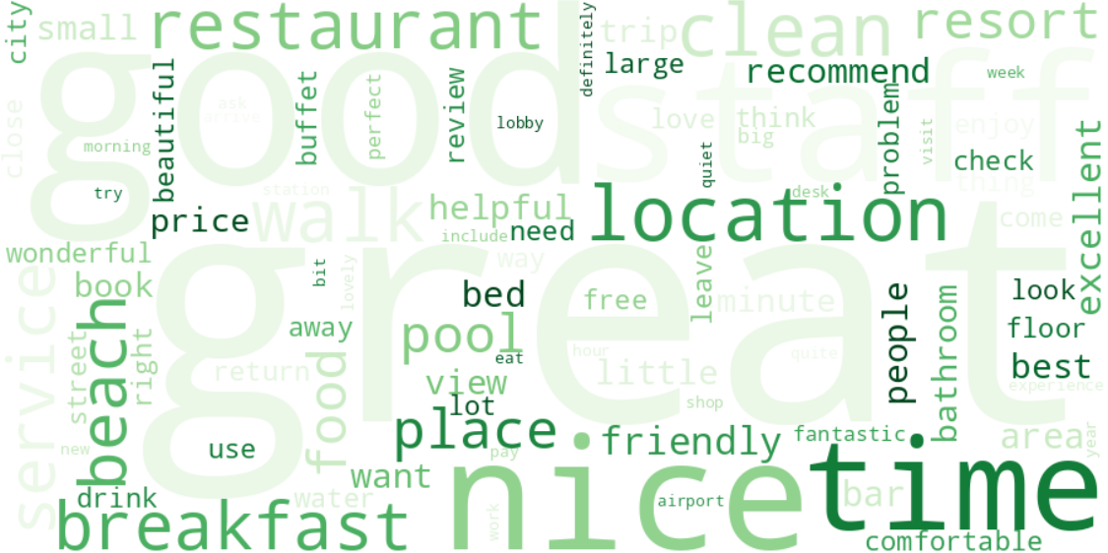
Figure 6. Most frequent lemmas in 4-5 star reviews.
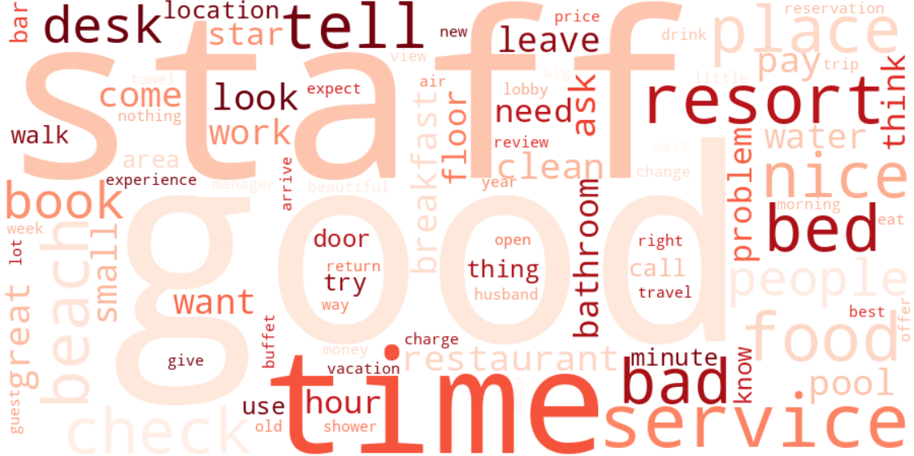
Figure 7. Most frequent lemmas in 1-2 star reviews.
Frequency clouds are dominated by shared vocabulary (location, staff, service, area, desk), because happy and unhappy guests write about the same things. They show what guests talk about, not how they feel about it, so the next views compare the two groups directly.

6.2 Terms that separate positive from negative reviews
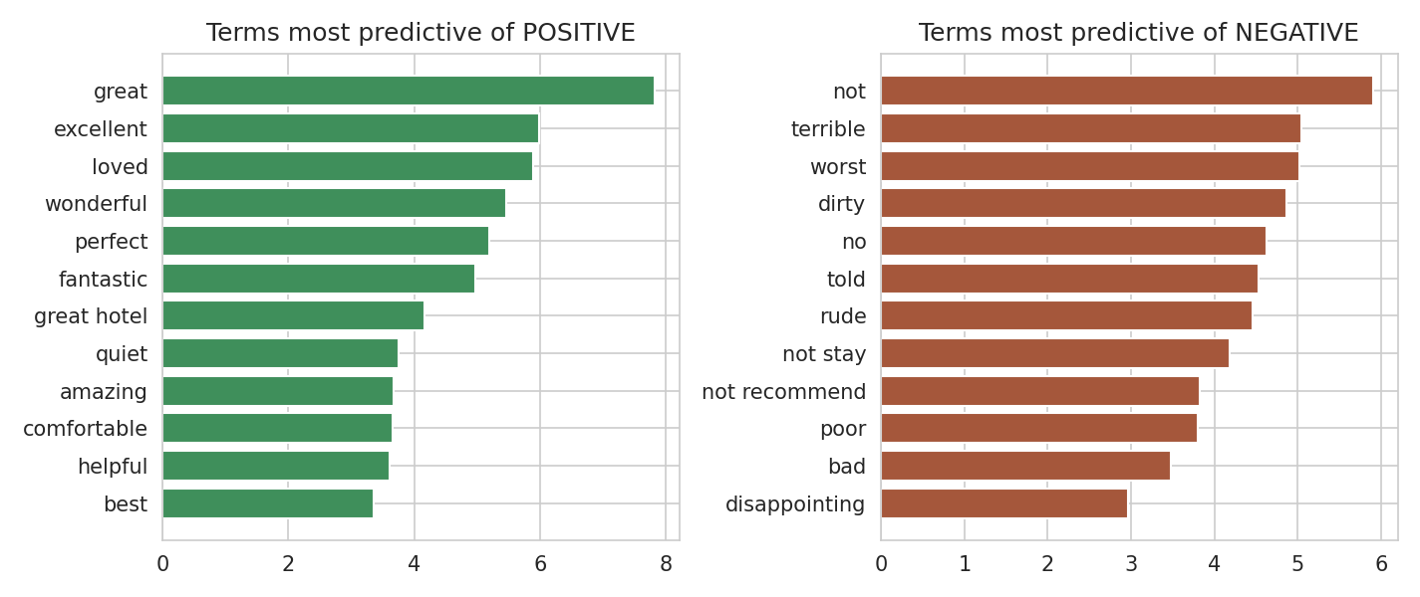
Figure 8. Largest logistic-regression weights for the positive and negative classes.
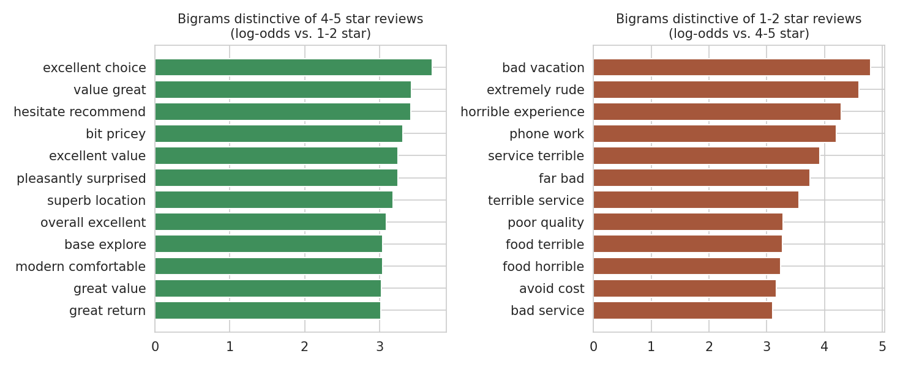
Figure 9. Word pairs most characteristic of each group (log-odds ratio, at least 25 occurrences).
Praise centres on value, location and a sense of confidence in recommending the hotel ('excellent value', 'superb location', 'hesitate recommend'). Complaints centre on service failures and strong wording ('extremely rude', 'terrible service', 'horrible experience', 'poor quality') and on practical breakdowns ('phone work'). A pair that appears among positive reviews, 'bit pricey', shows that price is noticed even by satisfied guests.

6.3 Topics in negative reviews (LDA)
Latent Dirichlet Allocation with five topics was fitted to the 3,214 reviews rated 1-2 stars. Topic labels are my interpretation of the top words.
Topic (my label) | Top words | Share of negative reviews
Front desk and check-in problems | check, tell, desk, ask, call, time, service, manager | 20%
Resort, beach and food | resort, beach, food, good, time, people, pool, restaurant | 23%
Restaurant and pool service | service, restaurant, pool, breakfast, food, staff, good, area | 11%
Bathroom, bed and room condition | bathroom, bed, shower, floor, place, door, clean, look | 21%
Price, size and expectations vs. location | good, location, staff, bed, small, book, great, price | 25%

The topics are only partly clean; the last one mixes positive words (good, great, nice) because low-star reviews also contain praise. The two clearest complaint themes are front-desk interaction and the physical condition of the room.

6.4 Aspect-based sentiment
Each clause containing a keyword for an aspect was scored with VADER and averaged per review. This links sentiment to a specific part of the stay.
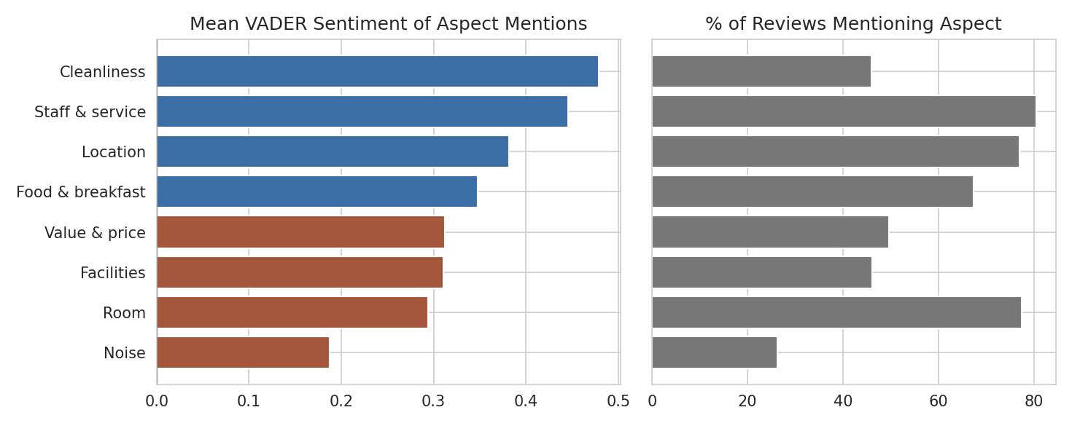
Figure 10. Mean sentiment of aspect mentions (orange = below the median aspect) and how often each aspect is mentioned.
Aspect | Reviews mentioning | Mean sentiment | Positive mentions | Negative mentions
Noise | 26.3% | 0.187 | 54.1% | 24.3%
Room | 77.5% | 0.294 | 73.2% | 13.4%
Facilities | 46.1% | 0.311 | 72.4% | 12.6%
Value & price | 49.7% | 0.312 | 71.1% | 14.9%
Food & breakfast | 67.3% | 0.348 | 76.3% | 11.2%
Location | 77.0% | 0.382 | 79.8% | 8.2%
Staff & service | 80.5% | 0.446 | 82.6% | 10.4%
Cleanliness | 46.0% | 0.479 | 84.2% | 10.3%

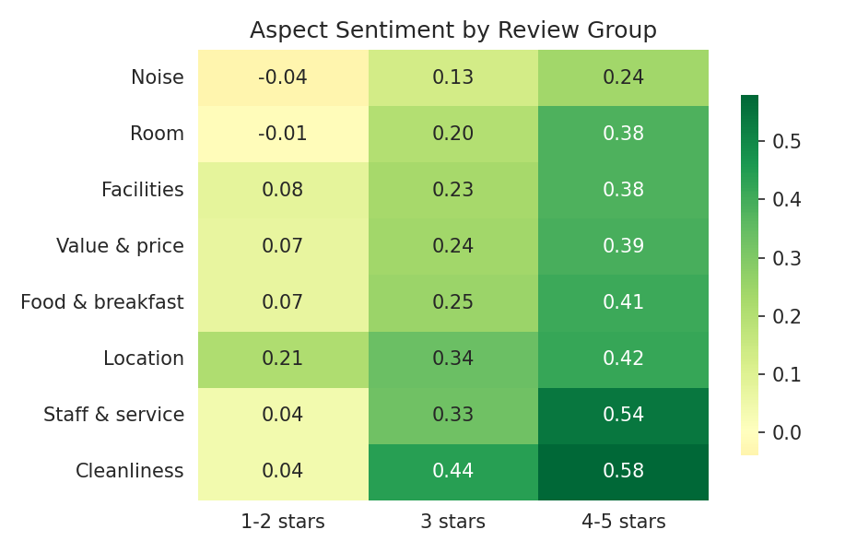
Figure 11. Aspect sentiment for 1-2 star, 3 star and 4-5 star reviews.
Aspect | Mentioned in 1-2 star reviews | Mentioned in 4-5 star reviews | Difference (points)
Cleanliness | 44.2% | 45.7% | -1.5
Facilities | 49.6% | 44.5% | +5.1
Food & breakfast | 58.2% | 68.9% | -10.7
Location | 60.0% | 79.9% | -19.9
Noise | 24.3% | 26.1% | -1.8
Room | 83.5% | 75.3% | +8.2
Staff & service | 75.2% | 82.4% | -7.2
Value & price | 56.8% | 46.6% | +10.2

Findings: (1) Cleanliness and staff/service have the most positive mentions, so these are the strengths of the hotels in this corpus. (2) Noise is the weakest aspect (0.187), with 24% of mentions negative. (3) Room is the second-weakest aspect and it is mentioned in 78% of reviews, so its weight in overall satisfaction is high. (4) Unhappy guests mention room (84% vs. 75%) and price (57% vs. 47%) more often than happy guests, while happy guests mention location far more often (80% vs. 60%). (5) Even in 1-2 star reviews the mean sentiment for most aspects is close to zero rather than strongly negative, which again reflects mixed wording.
Caution: aspect mean scores are all positive and differ by only a few tenths, so the ranking is informative but small differences (for example Food versus Value) should not be over-read. The keyword lists are hand-built, and some words are ambiguous ('hear' and 'sound' for noise, 'bar' and 'rate' for food and price).

7. Interpretation: Customer Satisfaction
- Overall satisfaction is high: 74% of reviews are 4-5 stars and 16% are 1-2 stars. Neutral 3-star reviews are 11%.
- Satisfaction is driven by people and place: staff, cleanliness and location produce the most positive language and the words most associated with recommending the hotel.
- Dissatisfaction is driven by specific failures rather than general dislike: rude or unhelpful front-desk encounters, room condition (bathroom, bed, noise), and price not matching expectations.
- Most negative reviews are mixed. Fewer than four in ten clauses in 1-star reviews are negative (39%), so a hotel that reads its worst reviews in full will find concrete, fixable items alongside the anger.
- Tools that give one score per review understate how many guests are unhappy. Dashboards built on default VADER would report roughly 92% positive sentiment when 74% of guests rated 4-5 stars and 16% rated 1-2 stars.

8. Recommendations

8.1 For hotel management
Priority | Action | Evidence in this analysis
1 | Front-desk and check-in standards: training on tone and problem resolution, clear escalation to a manager, working phone and call-back procedures | Largest complaint theme in LDA; 'extremely rude', 'terrible service' and 'phone work' are among the pairs most tied to low ratings; 75% of 1-2 star reviews mention staff
2 | Room condition audits (bathroom, bedding, fixtures) and clear room descriptions at booking | Room mentioned in 84% of 1-2 star reviews and has one of the lowest aspect scores; a separate LDA theme covers bathroom and bed; example of a suite not matching its description
3 | Noise control: soundproofing, room allocation away from lifts and corridors, quiet-floor option | Lowest aspect score (0.19); 24% of noise mentions negative
4 | Price and value communication: show total cost up front and match extras to guest expectations | Price mentioned more in low-star reviews (57% vs. 47%); 'bit pricey' appears even in positive reviews
5 | Use strengths in marketing: cleanliness, friendly staff, walking distance to attractions, value | Highest-scoring aspects and most positive word pairs
6 | Reply to mixed 2-3 star reviews first: they carry the most balanced feedback and name specific problems | Low-star reviews contain many positive clauses (28%-38%)

The frequent appearance of 'credit card' among the top word pairs in low-rated reviews suggests a payment or deposit issue, but no context was examined in this analysis, so it should be checked by reading the underlying reviews before acting.

8.2 For the analytics process
- Do not report default VADER or TextBlob scores as satisfaction on long reviews. Use clause-level scores or a model trained on the hotel's own reviews and ratings.
- Report macro-F1 alongside accuracy, and always compare with a majority-class baseline.
- Keep raw text (capitals, punctuation, contractions) in the review archive; the pre-processed version removed information that sentiment tools use.
- Collect date, hotel ID and trip type with each review to enable trend monitoring and property comparison.
- Track the share of negative clauses per aspect each month as a simple early-warning indicator.

9. Limitations
Limitation | Impact
Labels are star ratings, not human-annotated sentiment | Accuracy figures measure agreement with ratings, not with true sentiment; 3-star 'neutral' is a weak label
Text was pre-processed and partially damaged before I received it | Lowered lexicon performance in ways I cannot fully quantify; repairs are approximate
No dates, hotels or locations | No time trends; findings pool many hotels and destinations
Hand-built aspect keyword lists and comma-based clause splitting | Some misattribution; results indicative, not exact
Supervised model tested only on the same corpus | Performance on other platforms or languages is unknown
LDA topics are subjective and partly overlapping | Labels are interpretation
Only classical NLP methods | Transformer models, dependency parsing (spaCy) and sarcasm handling were not tested

10. Conclusion
Twenty thousand hotel reviews were repaired, cleaned and analysed with five sentiment approaches. Guests are largely satisfied (74% rated 4-5 stars), and their praise centres on staff, cleanliness and location. Their complaints centre on front-desk interactions, room condition, noise and price. The comparison of methods produced the most important technical lesson: default lexicon tools label about 92% of reviews positive and reach a macro-F1 of only 0.478, close to a trivial baseline, because long, mixed reviews saturate their scores. Scoring clause by clause improved the correlation with ratings from 0.46 to 0.58, and a TF-IDF logistic regression reached macro-F1 0.712. Data quality again mattered: the corpus had been stripped and partly corrupted, and knowing this shaped how the results should be read.

Appendix: Step-by-Step Pseudocode
1. LOAD reviews.csv -> columns: Review, Rating
2. LABEL rating 1-2 = negative, 3 = neutral, 4-5 = positive
3. REPAIR text: fix garbled apostrophes; 'n't' -> 'not'
4. FOR each review:
tokens = lowercase alphabetic words
tagged = pos_tag(tokens)
lemmas = WordNet lemma of each word (using its POS)
clean = lemmas without stop words / domain words
5. SCORE each repaired review with VADER and TextBlob
6. SPLIT into 80% train / 20% test (stratified by label)
7. TUNE lexicon cut-offs on train only (grid search, macro-F1)
8. FIT TF-IDF (1-2 grams) + logistic regression on train; choose C on test macro-F1
9. EVALUATE all methods on test: accuracy, macro-F1, confusion matrix
10. FOR each review: split into clauses, score each, keep mean / min / share negative
11. FOR each aspect: average the scores of clauses that contain its keywords
12. COUNT bigrams; compute log-odds (negative vs. positive); fit LDA on negative reviews
13. DRAW charts and word clouds; write results to JSON / CSV

The full Python script (sentiment.py) is supplied with this report.

References
Blei, D. M., Ng, A. Y., & Jordan, M. I. (2003). Latent Dirichlet allocation. Journal of Machine Learning Research, 3, 993-1022.
Bird, S., Klein, E., & Loper, E. (2009). Natural Language Processing with Python. O'Reilly Media.
Hutto, C. J., & Gilbert, E. (2014). VADER: A parsimonious rule-based model for sentiment analysis of social media text. Proceedings of ICWSM-14.
Loria, S. (2018). TextBlob: Simplified text processing. https://textblob.readthedocs.io
Pedregosa, F., et al. (2011). Scikit-learn: Machine learning in Python. Journal of Machine Learning Research, 12, 2825-2830.
TripAdvisor Hotel Reviews dataset (public CSV, 20,491 reviews), accessed via a public GitHub repository (MainakRepositor/Datasets).

